Admissions arrangements 2023-24

Approved by: | [Name] | Date: [Date]
Last reviewed on: | [Date]
Next review due by: | [Date]

EWELME C.E. PRIMARY SCHOOL ADMISSION ARRANGEMENTS 2023/24
Ewelme CE Primary School values highly its Christian ethos, its close links with local churches and the Diocese of Oxford. We provide a distinctively Christian, yet inclusive, environment in which each child is motivated to acquire skills for life and a love of learning. As a church school, we welcome applications from Christian families, and those of other faiths or none. We ask all parents applying for a place at our school to respect this ethos and its importance to the whole school community.
The governors have made every effort to ensure that these arrangements comply with the School Admissions Code 2021 and all relevant legislation, including that on infant class sizes and equal opportunities.
Admission arrangements to the Reception Year in September 2023
At our school, pupils are normally admitted at the beginning of the school year (1 September – 31 August) in which they reach their fifth birthday. Parents whose children were born between 1 September 2018 and 31 August 2019 may apply for them to be admitted to the Reception Year in September 2023. There are 13 places (the published admission number or PAN) available.
Parents of a child whose fifth birthday falls between 1 September 2023 and 31 March 2024 may defer entry until their child reaches compulsory school age (the term beginning in January or April after his or her fifth birthday). The school will hold the deferred place for the child (provided it is taken up during the school year 2023/24), although, in the great majority of cases, we find that children benefit from starting at the beginning of the school year, rather than part way through it.
For children whose fifth birthday falls between 1 April 2024 and 31 August 2024 (summer born children) who do not reach compulsory school age until September 2023, parents who do not wish them to start school in school year 2023/24 but to be admitted to the Reception Year in September 2024 should proceed as follows: They should apply at the usual time for a place in September 2023 together with a written request that the child is admitted outside his or her normal age group to the Reception year in September 2024. NB parents would need to provide supporting reasons for seeking a place outside the normal age group and should discuss the position with the head teacher as early as possible. The school will consider the request carefully and, if it is agreed, this should be clear before the national offer day (17th April 2023), and their application for the normal age group may be withdrawn before any place is offered. They should then reapply in the normal way (no later than 15 January 2024) for a Reception place in September 2024. If their request is refused, the parents must decide whether to wait for any other offer of a place in September 2023 (NB it will still be subject to the over-subscription criteria below) or to withdraw their application and apply in the second half of the of the summer term 2024 for a Year 1 place in September 2024. Parents should be aware that the Year 1 group may have no vacancies and it could be full with children transferring from the 2023/24 Reception Year group. NB agreement by the school in 2023 to defer does not guarantee a place in September 2024 – the normal over-subscription criteria apply.
Until the child reaches compulsory school age, s/he may attend part-time. If parents wish to exercise this right they should discuss detailed arrangements with the head teacher.
Parents (see Note 1) wishing to apply for the Reception [Foundation] Year in September 2023 must complete the common application form provided by their home local authority (the home LA). The home LA is the LA in whose area the parents live at the time of the application. The form must be returned to that LA no later than 15 January 2023. Applications received after this date will normally only be considered after all those received on or before the cut-off date Offers and refusals of places will be sent by the home LA on 17 April 2023.

Over-subscription criteria
Children with an Education, Health and Care (EHC) plan naming Ewelme CE Primary School will always be offered places. If there are fewer applications than places available, all children will be offered places. If there is greater demand for admission than there are places available, the following criteria will be applied in the order set out below:
1. Looked-after children and children who were previously looked after, including those children who appear to have been in state care outside England, but ceased to be so as a result of being adopted. (See Note 2)
2. Families who have exceptional medical or social needs that make it essential that their child attends Ewelme CE Primary School rather than any other. These needs must be fully supported by written evidence from the appropriate professional person involved with the family. (See Note 3)
3. Children with a normal home address (See Note 4) within the boundaries Ewelme and with a sibling (see Note 5) on the roll of the school at the time of application or whose parent has accepted an offer of a place at the school and who is expected still to be in attendance at the time of entry to the school.
4. Children with a normal home address within the boundaries Ewelme.
5. Children with a normal home address outside the boundaries of Ewelme and with a sibling on the roll of the school at the time of application or whose parent has accepted an offer of a place at the school and who is expected still to be in attendance at the time of entry to the school.
6) A child who lives within the parishes of Brightwell Baldwin or Cuxham with Easington** and one of whose parents (*3) is an active member of Ewelme, Brightwell Baldwin or Cuxham with Easington Church or any other Christian Church which is a member of Churches Together in Britain and Ireland or the Evangelical Alliance or another Christian Church ascribing to the doctrine of the Trinity and wishes them to receive a Church of England education. ‘Active’ is defined as having attended Church on a regular basis (at least once a month) in the twelve months prior to the date of this application. Your application must be supported by a completed Supplementary Information Form (available from school or online from the LA) and signed, as indicated, by the Priest in Charge. Attendance at any previous church taken together with that at any present one will be taken into account where necessary to prove the length of regular attendance. It would then be necessary to provide two (or more) SIFs – one from each church attended. (The supplementary form/s should be returned directly to Ewelme School no later than 15 January 2020) [The boundaries of the parishes of Brightwell Baldwin and Cuxham with Easington were defined by the Governors in February 2007 and are available for inspection in this policy; in the school office; on the school web site and the LA web site. A copy may also be obtained by post or email on request].
7) Other children.
Proximity of the child’s home, as measured by the straight line distance (see Note 6) between the home and the school with those living nearer being accorded the higher priority, will serve to differentiate between children in criteria 1 to 6 should the need arise. In the event that two distance measurements are identical, the school will use random allocation to decide which child should be offered the place. The process will be conducted in the presence of a person independent of the school.
All Other Admissions
Admission to the school during the school year depends on whether or not there are places available. All year groups at the school have 13 places. Applications must be made directly to Oxfordshire County Council using a form available on their website or by request from the LA.
If there is a vacancy, and there is no child on the relevant waiting list with a higher priority (according to the over-subscription criteria 1-6 above), a place will be offered.
In-year admissions or admissions at the beginning of school years other than Reception will only be considered by the Governing Body up to half a term [using the three-term year] in advance of the desired date for entry. For example, for entry in January, the application will not be considered until after the October half term break. Please note that the school does not have a normal point of entry to Year 3 – applications for entry at the beginning of Year 3 are treated as indicated in this section.
If parents are moving house, the school will ask for evidence of the move, when considering any application for a place. Documentary evidence in the form of a solicitor’s letter to confirm exchange of contracts, or a rental agreement for at least a period of six months will be required (Armed Forces personnel and crown servants are exempt). If you are returning from elsewhere, to live in a home that you own, we will require evidence to show that you have returned. We will also ask for evidence that any previous house owned has been sold or is being sold. We would not accept an address where the one given is that of a second home with the main home being elsewhere. If there are two or more homes, we will check which is the main home, and may refuse to base an allocation of a place on an address which might be considered only temporary. Nor would we accept an address where the child was resident other than with a parent or carer unless this was part of a fostering or formal care arrangement. We would not normally accept an address where only part of a family had moved, unless connected with a divorce or permanent separation arrangement, in which case we would require proof.
Admission outside normal age group
Requests from parents for places outside a normal age group will be considered carefully, e.g. for those who have missed education due to ill health. Each case will be considered on its own merits and circumstances. However, such admissions will not normally be agreed without a consensus that to do so would be in the pupil’s interests. It is recommended that parents discuss their wishes with the head teacher in advance of applying for a place. The governors may ask relevant professionals for their opinion on the case. It should be noted that if a place in the requested age group is refused, but one in the normal age group is offered, then there is no right of appeal.
Waiting Lists
The school maintains waiting lists for those children who are not offered a place, and the parents ask for the child’s name to be added to the waiting list. The order of priority on the waiting list is the same as the list of criteria for over-subscription, and does not depend on the date on which an application is received. No account is taken of length of time on a waiting list. The school periodically seeks confirmation that parents wish a child to be kept on the waiting list.
Multiple births
In cases where there is one place available, and the next child on the list is a twin, triplet, etc., we would admit both twins (and all the children in the case of other multiple births) even if this meant exceeding the agreed admission number of 13 for Reception 2023/24 or the number of places in other year groups.
Fair Access
The school participates in Oxfordshire LA’s Fair Access Protocol. Children qualifying under the Fair Access Protocol may be offered a place even if there are no places available in the relevant year group and also take priority for admission over any child on the waiting list.
Appeals
There are established arrangements for appeals against non-admission. Details are available from the school, including the date by which an appeal should be submitted. It should be noted that, in the event of an unsuccessful appeal against non-admission to the school, the school does not consider any further application in the same school year (1 September – 31 August), unless there has been a material change in circumstances, for example a change of address which results in a move from outside the catchment area to inside it.
Parents who wish their children to attend the school are most welcome to visit. Arrangements can be made through the School Business Manager, Sandra Denton, at the school.
Admissions in September 2022 (This information will be added once known)
The school received ___ applications expressing a preference for admission to the Reception Year in 2022 by the closing date in January 2022. These were ranked as follows:
Children with statements or EHC plans naming the school
Criterion 1
Criterion 2
Criterion 3
Criterion 4
Criterion 5
Criterion 6
Criterion 7
Criterion 8
____ places were offered, with the cut-off coming under criterion ___ at a distance of ___ miles.
Admissions in September 2022 took place according to our previous admissions policy. Our admissions arrangements have been changed and replaced by this document. Changes to our admissions arrangements include a reduction in the number of over-subscription criterions from 8 (as shown above) to 6 (as outlined on page 3).
Further information
Further information can be obtained from the School Business Manager at the school.
Email: office.3752@ewelme.oxon.sch.uk
Telephone: 01491 839240
Notes
Note 1:
“Parent” is defined in law (The Education Act 1996) as either:
a) any person who has ‘parental responsibility’ (defined in the Children Act 1989) for the child or young person; or
b) any person who has care of the child or young person.
If you are in any doubt, please contact the school for advice.
Note 2:
By a “looked-after child” we mean one in the care of a local authority or being provided with accommodation by a local authority in the exercise of its social services function. Previously looked after children are children who have been adopted, subject to child arrangement orders or special guardianship orders. Adopted children are those for whom an adoption order is made under the Adoption Act 1976 (Section 12) or the Adoption and Children Act 2002 (Section 46). A ‘child arrangements order’ is one settling the arrangements to be made as to the person with whom the child is to live (Children Act 1989, Section 8, as amended by the Children and Families Act 2014, Section 14). A ‘special guardianship order’ is one appointing one or more individuals to be a child’s special guardian/s (Children Act 1989, Section 14A). Applications under this criterion must be accompanied by evidence to show that the child is looked after or was previously looked after (e.g. a copy of the adoption, child arrangements or special guardianship order). Evidence that a child from outside England was previously in state care will be required to come within this criterion. A child is regarded as having been in state care outside England if they were in the care of or were accommodated by a public authority, a religious organisation, or any other provider of care whose sole or main purpose is to benefit society.

Note 3:
When applying under criterion 2 (exceptional medical or social needs), you must include supporting evidence from an independent professional person who is aware of the situation and supports your reasons for preferring Ewelme CE Primary School. This supporting evidence must clearly demonstrate why the school is the most suitable and must illustrate the difficulties that would be caused if your child had to attend another school. The person supplying the evidence should be a doctor, heath visitor, social worker, etc. who is aware of your child’s or your own case. The school reserves the right to ask for further evidence or clarification where necessary and may seek the advice of appropriate educational professionals where necessary.
Note 4:
By normal home address, we mean the child’s home address. This must be where the parent or legal carer of the child lives with the child unless it is proved that the child is resident elsewhere with someone else who has legal care and control of the child. The address should be a residential property that is owned, leased or rented by the child’s parent/s or person with legal care and control of the child.
To avoid doubt, where a child lives with parents with shared responsibility, each for part of a week or month, the address where the child lives will be determined having regard to a joint declaration from the parents stating the exact pattern of residence. If the residence is not split equally, then the relevant address used will be that at which we are satisfied that the child spends the majority of the school week. Where there is an equal split or there is any doubt about residence, we will make the judgment about which address to use for the purpose of determining whether or not to offer a place. We will take into account, for example, the following:
• any legal documentation confirming residence
• the pattern of the residence
• the period of time over which the current arrangement has been in place
• confirmation from any previous school of the contact details and home address supplied to it by the parents
• where the child is registered with his/her GP
• any other evidence the parents may supply to verify the position.
We may ask for evidence of the normal home address in the form of a recent bill. This could be, for example, the most recent Council Tax bill, utility bill no more than three months old, a current TV licence, buildings and contents insurance, mortgage statement or rent book which shows the address concerned. Parents who are unable to provide this evidence should contact the school to discuss what evidence might be acceptable. If it becomes clear or if there is any doubt that the parents and child are not living at the address given on the application form, the school may seek further evidence. The school works closely with the LA to ensure that places are not obtained at the school on the basis of false addresses, and, in cases of doubt, will take steps to verify the information provided. If a place at the school is offered, and it later becomes clear that the offer was made on fraudulent or misleading information (e.g. a false claim to living in the catchment area), and the school has denied a place to a child with a stronger claim, the school will withdraw the offer of a place. The offer can also be withdrawn even after the child has started at the school.
We regard a child’s home address to be where he or she sleeps for the majority of the school week (Monday to Friday). We may ask to see official documentation, such as a child benefit 18 book or medical card if there are reasons why a child does not live at his or her parent’s address. For example, if he or she is resident with a grandparent, this needs to be made clear on the application form. If such arrangements are not declared or a relative’s address is used on the application, we may consider that a false declaration has been made, and withdraw the offer of a place. Childcare arrangements are not sufficient reason for listing another address.
If parents move house after the application has been made, but before any offer of a place has been made, the home LA must be informed.
If parents are moving, we will ask for evidence of the move, when considering any application for a place under the co-ordinated scheme.
We would not accept an address where the one given is that of a second home with the main home being elsewhere. If there are two or more homes, we will check which is the main home, and may refuse to base an allocation of a place on an address which might be considered only temporary. Nor would we accept an address where the child was resident other than with a parent or carer unless this was part of a fostering or formal care arrangement. We would not normally accept an address where only part of a family had moved, unless connected with a divorce or permanent separation arrangement, in which case we would require proof.
There are special arrangements for families of service personnel with a confirmed posting or crown servants returning from overseas. If the application is accompanied by an official letter that declares the relocation date, and if there is a place available, it will be offered even though there is not an intended address or the family is not yet living in the area.
Note 5:
By sibling we mean a brother or sister, half brother or sister, adopted brother or sister, step brother or sister, or the child of the parent’s/carer’s partner where the child for whom the school place is sought is living in the same family unit at the same address as that sibling. It is helpful if parents make it clear on the application form where the sibling has a different family name. Where there is more than one sibling at the school, only the youngest should be listed on the application form.
Note 6:
The straight line distance used to determine proximity of the home to the school will be measured by Oxfordshire LA’s Geographical Information System.
Catchment area maps:
The maps 1-4 below show the four parishes that constitute the Ewelme Benefice. MAP 2 (Ewelme Parish) shows the school’s catchment area. The catchment area is also shown in the yellow area of MAP 5.
Parish maps of Ewelme, Brightwell Baldwin, Cuxham and Easington may also be found on the Church of England website or by following this link: www.achurchnearyou.com
MAP 1: Cuxham parish MAP 2: Ewelme parish
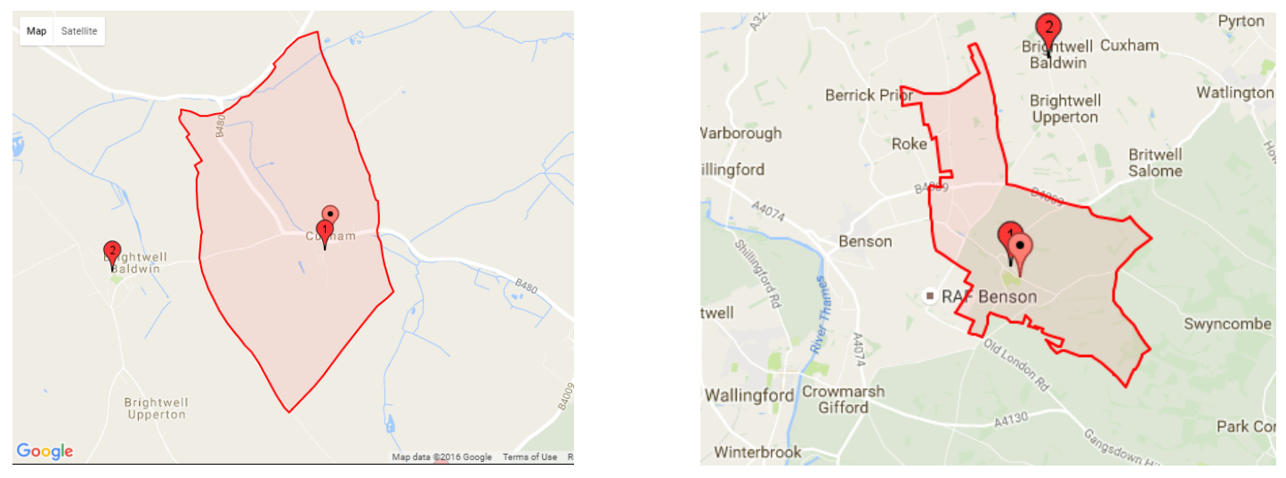
MAP 3: Brightwell Baldwin parish MAP 4: Easington parish
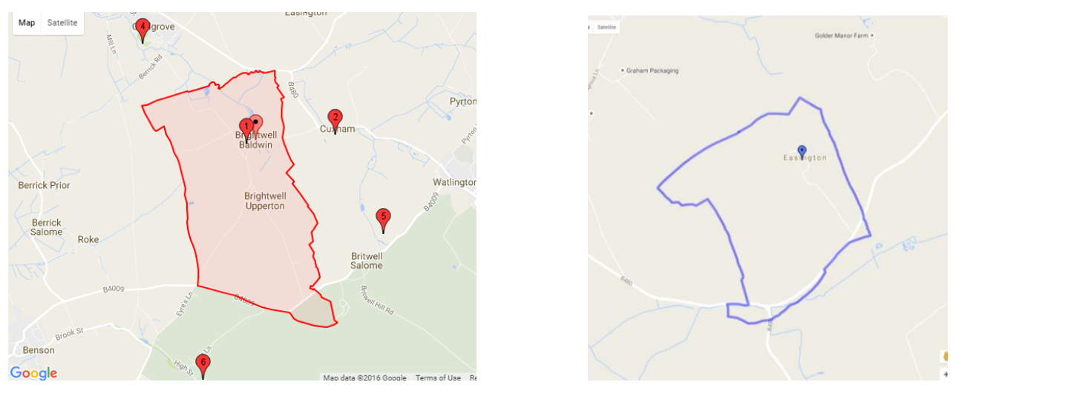

MAP 5:
