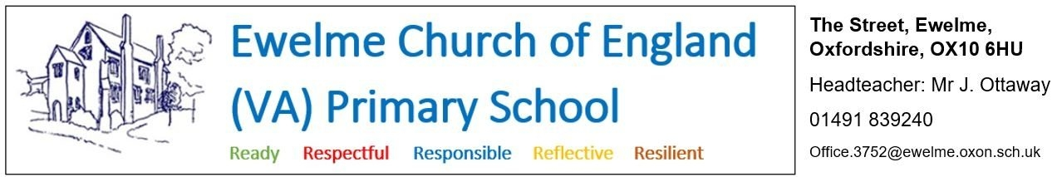

**Position: Teaching assistant (with lunchtime supervision responsibilities)**

**Hours: - 10 hours per week**

Flexible hours and days/times of work can be discussed. This role could be fulfilled in conjunction with a admin assistant and/or breakfast and ASC playworker role within the school (see separate job adverts).

**Salary: - Grade 4 (£13.43-£13.65 per hour)**

**Ewelme C.E. Primary School are looking to recruit a new, part-time teaching assistant to support the teaching and learning at our wonderful school.**

The successful candidate will work with individuals, groups of children and whole year groups (approximately 13 children).

What Ewelme can offer:

* A friendly and supportive team
* Well behaved and engaged pupils
* A beautiful school site, set on the edge of the Chilterns AONB, and housed in a 600 year-old medieval complex of buildings

What we are looking for:

* A hard working, resilient, positive individual with a willingness to reflect and improve
* A team player who can work closely and collaboratively with teachers and support staff to: support learning; work with individuals and small groups; deliver interventions, phonics, maths and English teaching sessions; supervise children in the hall, playground and field at lunchtime; and prepare and organise classroom resources.

**Applications should be made using the Oxfordshire County Council application form and be emailed to** [**office.3752@ewelme.oxon.sch.uk**](mailto:office.3752@ewelme.oxon.sch.uk) **or posted to Ewelme C.E. Primary School, The Street, Ewelme, Oxon, OX10 6HU.** A link to the form, and more information about the school, can be found at: [www.ewelmeprimaryschool.com/vacancies/](http://www.ewelmeprimaryschool.com/vacancies/)

If you wish to speak with the head teacher to discuss the post, or arrange a visit to the school, please email [head.3752@ewelme.oxon.sch.uk](mailto:head.3752@ewelme.oxon.sch.uk) . If you are interested in this role, we would love to hear from you and to give you the opportunity to discuss the job and ask questions before you apply.

**Application deadline:** Monday 8th July 2024

**Date of interviews:** Thursday 11th July 2024

**Start date:** September 2024

**Safer Recruitment** - Oxfordshire Schools are committed to safeguarding and promoting the welfare of children and young people and expect all staff and volunteers to share this commitment. All applicants are required to undertake a Disclosure and Barring Service check. The possession of a criminal record will not necessarily prevent an applicant from obtaining a post. All cases are considered confidentially and according to the nature of the role and information disclosed.