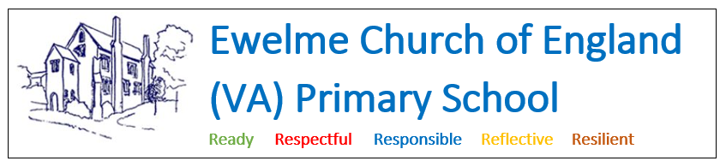

Non-collection of Children Policy

Statement of intent
In the event that a child is not collected by an authorised adult at the end of a school session, Ewelme Primary School puts into practice agreed procedures.

Aim
In the event that a child is not collected by an authorised adult, we will ensure that the child receives a high standard of care in order to cause as little distress as possible. We inform parents/carers of our procedures so that, if they are unavoidably delayed, they will be reassured that their children will be properly cared for.

Procedures
1. Parents/carers of children starting at Ewelme CE Primary School are asked to provide specific information, which is recorded confidentially in our electronic systems and in paper form in emergency contact files stored in the school office.

The contact information includes:
- home address and telephone number - if the parents/carers do not have a telephone, an alternative number must be given (e.g. a neighbour's or other close family member)
- work telephone number (if applicable)
- mobile telephone number (if applicable)
- names and telephone numbers of adults who are authorised by the parents/carers to collect their child from school, for example a childminder or grandparent
- information about any person who does not have legal access to the child.

PLEASE ADVISE THE SCHOOL OF ANY CHANGE OF INFORMATION IMMEDIATELY

2. On occasions when parents/carers are aware that they will not be at home or in their usual place of work, they should inform us how they can be contacted.

3. On occasions when parents/carers are unable to collect a child, they should inform the class teacher/school wherever possible, at the start of the school day, or by telephone, prior to the end of the session.

4. In the event that a child is not collected by an authorised adult, school staff will remain with the child at all times. They will wait on the playground for up to15 minutes with the child. Then the child will be brought into the school buildings and supervised whilst contact is attempted using emergency contact numbers. This supervision may include the placement of the child in after-school club assuming this is not already full.

5. If no contact can be made with parents or authorised carers, and the staff can no longer supervise the child on the premises – the safeguarding children procedures are applied as set out in the safeguarding children policy.

The procedures are as follows:
- Email inboxes and the telephone answer machine are checked for any information about changes to the normal collection routines.
- If no information is available, parents/carers are contacted at home or at work.
- If this is unsuccessful, the adults who are authorised by the parents to collect their child from the setting - and whose telephone numbers are recorded on the Registration Form - are contacted.
- All reasonable attempts are made to contact the parents or nominated carers.
- The child does not leave the premises with anyone other than those named on the Registration Form and in the Emergency Contacts file.
- If no-one collects the child after one hour and there is no-one who can be contacted to collect the child, we will apply the procedures for uncollected children.
(Telephone number for Assessment Team South Tel: 01865 897983)
- The child stays at the school in the care of 2 DBS-checked members of staff until the child is safely collected either by the parents or by a social worker.
- Children’s Services will aim to find the parent or relative. If they are unable to do so, the child will be admitted into the care of the local authority.
- Under no circumstances are staff to go to look for the parent, nor do they take the child home with them.
- A full written report of the incident is recorded in the child's file.
- Ofsted must be informed (telephone number 08456 40 40 40).

