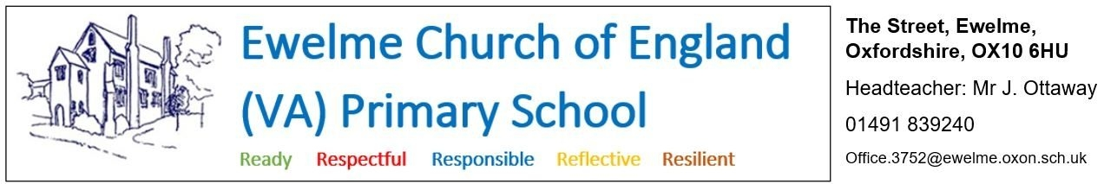

**Position: Administration assistant**

**Hours: - 7.75 hours per week**

Flexible hours and days/times of work can be discussed with the head teacher. This role could be fulfilled in conjunction with a teaching assistant and/or breakfast and ASC playworker roles within the school (see separate job adverts).

**Salary: - Grade 4 (£12.65-£12.85 per hour)**

We are looking to recruit a positive, hard-working and well-organised administration assistant to support the running of our small, friendly school, alongside our experienced and knowledgeable school business manager.

The role will involve routine general clerical, administrative and financial support, including reception work (dealing with phone calls and enquiries, signing visitors in and out etc.) day-to-day admin tasks (registers, checking on absent pupils, regular health and safety checks) and other general responsibilities (such as routine financial administration, photocopying, organising resources and supplies).

**What Ewelme can offer**:

* A friendly and supportive staff team
* Engaged and well-behaved children
* A beautiful school site, set on the edge of the Chilterns AONB, and housed in a 600 year-old complex of medieval buildings
* Direction and support from an experienced and knowledgeable school business manager

**Applications should be made using the Oxfordshire County Council application form and be emailed to** [**office.3752@ewelme.oxon.sch.uk**](mailto:office.3752@ewelme.oxon.sch.uk) **or posted to Ewelme C.E. Primary School, The Street, Ewelme, Oxon, OX10 6HU.** A link to the form, and more information about the school, can be found at: [www.ewelmeprimaryschool.com/vacancies/](http://www.ewelmeprimaryschool.com/vacancies/)

If you wish to speak with the head teacher to discuss the post, or arrange a visit to the school, please email [head.3752@ewelme.oxon.sch.uk](mailto:head.3752@ewelme.oxon.sch.uk) . If you are interested in this role, we would love to hear from you and to give you the opportunity to discuss the job and ask questions before you apply.

**Application deadline:** Monday 9th June 2025 at 9am

**Date of interviews:** Thursday 19th June 2025 and Friday 20th June 2025

**Start date:** September 2025

**Safer Recruitment** - Oxfordshire Schools are committed to safeguarding and promoting the welfare of children and young people and expect all staff and volunteers to share this commitment. All applicants are required to undertake a Disclosure and Barring Service check. The possession of a criminal record will not necessarily prevent an applicant from obtaining a post. All cases are considered confidentially and according to the nature of the role and information disclosed.