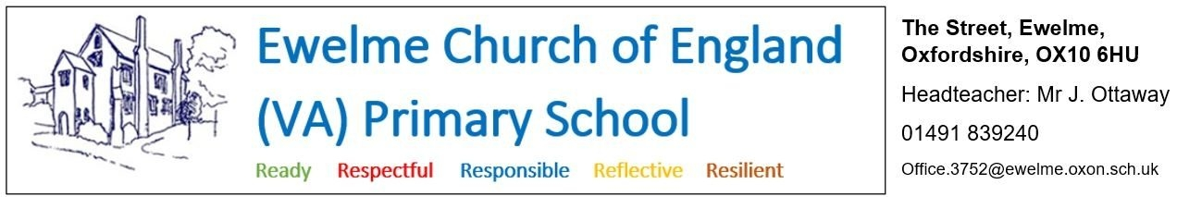

**Position: Breakfast and After-School Club playworker**

**Hours: - 11.75 hours per week, made up of:**

Breakfast Club – 8am-8.45am Monday-Friday: 3.75 hours per week

After-School Club -3.15pm – 5.15pm Monday-Thursday: 8 hours week

Flexible hours can be discussed and the role may be suitable for a job share. This role could be fulfilled in conjunction with a teaching assistant and/or admin assistant role within the school (see separate job adverts).

**Salary: - Grade 4 (£12.65-£12.85 per hour)**

We are looking to recruit an energetic and enthusiastic playworker to provide supervision and support during our breakfast and after-school clubs here at Ewelme. The successful candidate will support the planning, day-to-day organisation and operation of the club, providing high quality play opportunities and care for children in an inclusive environment, and in accordance with the school’s ethos and procedures.

**What Ewelme can offer**:

* A friendly and supportive staff team
* Engaged and well-behaved children
* A beautiful school site, set on the edge of the Chilterns AONB, and housed in a 600 year-old complex of medieval buildings
* School hall and extensive outdoor space that can be used by Breakfast and After-School Club
* A variety of arts/crafts resources, toys, games, books and other indoor and outdoor activities that can be used during Breakfast and After-School Club

**Applications should be made using the Oxfordshire County Council application form and be emailed to** [**office.3752@ewelme.oxon.sch.uk**](mailto:office.3752@ewelme.oxon.sch.uk) **or posted to Ewelme C.E. Primary School, The Street, Ewelme, Oxon, OX10 6HU.** A link to the form, and more information about the school, can be found at: [www.ewelmeprimaryschool.com/vacancies/](http://www.ewelmeprimaryschool.com/vacancies/)

If you wish to speak with the head teacher to discuss the post, or arrange a visit to the school, please email [head.3752@ewelme.oxon.sch.uk](mailto:head.3752@ewelme.oxon.sch.uk) . If you are interested in this role, we would love to hear from you and to give you the opportunity to discuss the job and ask questions before you apply.

**Application deadline:** Monday 9th June 2025 at 9am

**Date of interviews:** Thursday 19th June 2025 and Friday 20th June 2025

**Start date:** September 2025

**Safer Recruitment** - Oxfordshire Schools are committed to safeguarding and promoting the welfare of children and young people and expect all staff and volunteers to share this commitment. All applicants are required to undertake a Disclosure and Barring Service check. The possession of a criminal record will not necessarily prevent an applicant from obtaining a post. All cases are considered confidentially and according to the nature of the role and information disclosed.