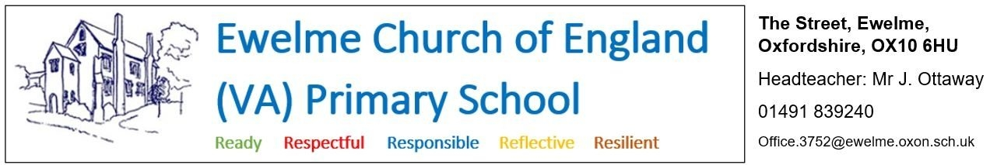

**Full-time Teaching Assistants (with lunchtime supervision responsibilities)**

**Hours: -** 8.45am – 3.20pm Monday-Friday. 30.5 hours per week. This role could be fulfilled in conjunction with the breakfast and after-school club roles advertised separately (see job advert). Flexible or part-time hours can be discussed with the right candidate.

**Salary: - Grade 4 (£12.65-£12.85 per hour) – Grade 6 (£13.47-£14.60 per hour) depending on experience of successful candidate**

**Ewelme C.E. Primary School are looking to recruit two full-time teaching assistants to support the teaching and learning at our wonderful school.**

The successful candidates will work with individuals, groups of children and whole year groups (approximately 13 children) across the school.

What Ewelme can offer:

* A friendly and supportive team
* Well behaved and engaged pupils
* A beautiful school site, set on the edge of the Chilterns AONB, and housed in a 600 year-old medieval complex of buildings

What we are looking for:

* A hard working, resilient, positive individual with a willingness to reflect and improve
* A team player who can work closely and collaboratively with teachers and support staff to: support learning; work with individuals and small groups; deliver interventions, phonics, maths and English teaching sessions; supervise children in the hall, playground and field at lunchtime; and prepare and organise classroom resources.

This is a full-time position that will start at 8.45am and finish at 3.20pm each day, although flexible or part-time hours can be discussed with the right candidate.

Applications should be made using the Oxfordshire County Council application form (link below) and be emailed to [office.3752@ewelme.oxon.sch.uk](mailto:office.3752@ewelme.oxon.sch.uk) or posted to Ewelme C.E. Primary School, The Street, Ewelme, Oxon, OX10 6HU.

If you wish to speak with the head teacher to discuss the post, or arrange a visit to the school, please call us on 01491 839240.