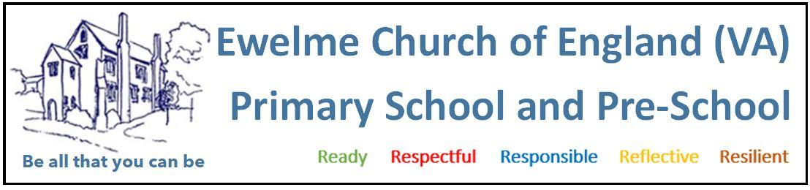POLICY ON FOOD SAFETY, ALLERGIES AND CULTURAL RESTRICTIONS

OUR COMMITMENT

The Early Years are a crucial time to reduce health inequalities and set the foundations for a lifetime of good health.

Ewelme Pre-School is committed to maintaining the highest standards of food hygiene and safety in line with statutory requirements and best practices.

Parents/carers are invited to provide their children with packed lunches to eat in the setting. The children

We adhere to the guidance set out in the Food Standards Agency’s “Safer Food, Better Business” toolkit and ensure that all food safety procedures are fully embedded in our day-to-day operations in collaboration with the new EYFS Nutrition Guidance May 2025.

Your child’s key person will liaise with you on an ongoing basis to ensure your child’s needs are being met.

FOOD HANDLING, PREPARATION, AND HYGIENE

We ensure all staff involved in food handling and preparation follow strict hygiene protocols, including:
- Staff exhibiting signs of illness are prohibited from handling food.
- All food preparation surfaces are cleaned before and after use with antibacterial spray and disposable cloths or kitchen roll.
- Colour-coded chopping boards are used correctly (e.g., red for raw meat) to prevent cross-contamination.
- Chopping boards, utensils, and equipment are thoroughly cleaned and disinfected after each use.
- Hand hygiene is strictly observed — staff wash hands with antibacterial soap and warm water before and after food preparation, after toilet use, and after changing nappies.
- Gloves are worn during food handling.
- Cuts or sores are covered with a blue waterproof dressing.
- Food Hygiene training certificates are held by all staff and regularly renewed.
- Paediatric 1st Aid – All staff working with children have paediatric 1st aid training.

CLEANING PROCEDURES

Fridge and Freezer Maintenance:

Please note that the preschool does not currently use the fridge or freezer located in the village hall kitchen to store any food that is served to the children. However, if the fridge or freezer were to be used by the preschool in the future, the following steps would be adhered to.

- Fridges are cleaned weekly: all shelves, drawers, and seals are washed with warm soapy water and disinfectant.
- All items are checked for expiry dates; out-of-date items are discarded appropriately.
- Freezers (non-frost-free) are defrosted and deep cleaned monthly.
- Fridge temperatures are checked daily and logged to ensure food is stored safely.

General Kitchen Cleaning:
- Worktops and food contact surfaces are cleaned before and after each use.
- Kitchen waste is disposed of promptly and hygienically.

Pest Control

We have a contract with a commercial Pest Control specialist with routine inspections in compliance with regulations to provide ongoing services to maintain a pest-free environment ensuring children’s, and staff’s health and safety.

HEALTHY EATING AND NUTRITION

At Ewelme Pre-School, we believe that a healthy, balanced diet is essential for a child’s physical and emotional development. We closely follow the EYFS Nutrition Guidance May 2025
- Where children are provided with snacks and drinks, these must be healthy, balanced and nutritious
- We promote positive food experiences and educate children on the importance of nutritious meals. Children’s early experiences with food can shape future eating habits. This can impact children’s long-term health including maintaining a healthy weight and good oral health.
- We ensure children get the right amount of nutrients and energy they need while they are growing rapidly, which is especially important for children who might not have access to healthy food at home. This can prevent children from becoming overweight or obese.
- Children are provided with healthy, balanced snacks appropriate to their age and dietary needs.
- Fresh drinking water is available to children throughout the day.
- Cultural, religious, ethical, and medical dietary requirements are always respected and accommodated.
(Please note that due to the pre-school being located in a communal village hall we cannot ensure nuts or other common allergens are entirely eliminated from our kitchen, which may be used by other community groups or events).
- To the greatest extent possible, Multicultural foods are included to ensure all children feel represented and to encourage an appreciation of global diets.

Parents are asked to inform us of any dietary requirements during registration. Where dietary preferences are based on non-medical needs, parents may be asked to supply suitable alternatives in sealed, labelled packaging.

FOOD ALLERGY AND INTOLERANCE MANAGEMENT

We take food allergies and intolerances extremely seriously and have comprehensive systems in place to manage risk:
- Allergy information is collected during registration and updated regularly.
- Individual care plans are created for children with food allergies/intolerances.
- Clear visual indicators such as:
  - Light blue plates/cups
  - Allergy information on the wall with child’s name and restriction
Staff training includes:
- Recognising signs of allergic reactions and anaphylaxis
- Administering emergency medication, antihistamine or EpiPen
- Reading food labels for allergens
- Cross-contamination prevention
Food allergen risk assessments and policies are reviewed regularly, and all allergy-related documentation is securely stored and accessible. This information must be given in writing by parents and the same when a child can be reintroduced to previously restricted food.

When planning snacks, all individual child’s needs are taken into consideration including allergies. In preschool and kitchen we have a list on display of all children that have allergies, intolerances, preferences and cultural restrictions and we check and double check that these are all respected.

Each plate for a child with allergies is colour coded.

SAFE FOOD STORAGE AND TEMPERATURE CONTROL

Please note that the preschool does not currently use the fridge or freezer located in the village hall kitchen to store any food that is served to the children. However, if the fridge or freezer were to be used by the preschool in the future, the following steps would be adhered to.

To prevent contamination and ensure food quality, we follow strict storage guidelines:
- Fridge temperatures are monitored daily and maintained at or below 5°C.
- Freezers are maintained at -18°C or lower.
- Dry foods are stored in cool, dry, pest-free areas in sealed containers.
- Cooked and raw foods are stored separately.
- All food is labelled and dated upon receipt and opening.

GUIDANCE FOR CHILDREN AGED 1 YEARS TO 5 YEARS

When preparing food, it is important to avoid round shapes as these are a choking hazard. Cut small fruits lengthways and then halve again (quarters). These fruits include:
    - grapes
    - Blueberries
    - strawberries
    - cherry tomatoes.

All children need a healthy balanced diet based on the 4 main food groups:

FRUIT & VEGETABLES
POTATOES, BREAD, RICE PAST & other starchy carbohydrates
DAIRY or dairy alternatives
BEANS, PULSES, FISH, EGGS, MEAT & other proteins

MONITORING AND REVIEW
This policy will be reviewed annually or in response to:
- Changes in food safety legislation
- Updates from the Food Standards Agency (FSA)
- EYFS Nutrition Guidance May 2025
- Parent or staff feedback
- New allergen advice or best practice guidance
Staff are encouraged to report any concerns or suggestions for improvement. We welcome contributions from parents and carers in keeping this policy effective and up to date.

Reviewed September 2025
Next review due September 2026

USEFUL INFORMATION –
https://assets.publishing.service.gov.uk/media/6839b752210698b3364e86fc/Early_years_foundation_stage_nutrition_guidance.pdf

Fruit/Veg supplied daily by parents, fruits washed and chopped by staff before serving as a fruit salad.
Food given on celebrations such as pancake day, chinese new year etc may be cooked by preschool staff and children.
Forest school- cooking over the fire- risk assessments carried out by forest school lead.
Large kitchen equipment, such as fridge, dishwasher, cooker, microwave, maintained by village hall and any concerns from us are raised to them via email.

