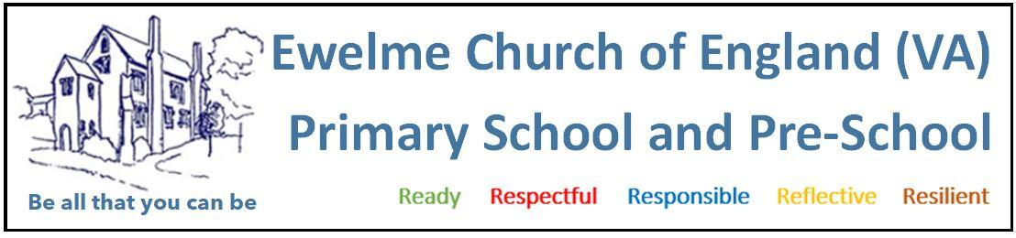

PRE-SCHOOL ABSENT CHILD POLICY

At Ewelme Pre-School, we are committed to ensuring the safety, wellbeing, and consistent development of every child. Regular attendance is vital for children to fully benefit from the experiences we offer. This policy outlines the expectations and procedures surrounding child absence from the setting.

REPORTING AN ABSENCE

If your child is unable to attend nursery on their scheduled day, you must notify us by 9:30am on the first day of absence and continue to inform us daily for the duration of the absence. You can report absences via:
- Telephone
- Class Dojo App
- Email

UNEXPLAINED ABSENCES

Children’s attendance is monitored closely. If we do not receive an explanation for your child’s absence by 10:00am, we will attempt to contact you. If we are unable to reach you within 48 hours and still have no explanation, we may be required to notify Children’s Services, in accordance with the Children Act 2004.

This procedure reflects guidance from the local authority.

The sole purpose of this policy is to protect the safety and welfare of the child and their family.

POLICY AIMS AND PRINCIBLES

This policy aligns with the vision and aims of Ewelme Pre-School by:
- Encouraging parents, carers, and staff to prioritise attendance to maximise children’s learning and development.
- Outlining clear procedures for parental involvement and attendance communication.

KEY PRINCIPLES
- Regular and punctual attendance is crucial for children’s learning and wellbeing.
- Children should arrive on time every day the setting is open, unless absence is unavoidable.
- Unjustified or unexplained absences will be marked as unauthorised.
- Parents should not conceal absences or make excuses. Open communication is essential.
- All absences must be classified by the setting, not the parent/carer.
As an Ofsted-registered early years provider, our attendance records are scrutinised and contribute to our overall setting evaluation. Your support in maintaining strong attendance is vital.

PARENTAL RESPONSIBILITIES
- Notify the nursery of your child’s absence by 9:30am on the first day and each day following.
- Use telephone, email, or the Class Dojo app to report absence.
- Work in partnership with the nursery to address any barriers to regular attendance.
- Attend meetings arranged to discuss ongoing or frequent absences.
STAFF RESPONSIBILITIES
- Complete registers at the beginning of each morning and afternoon session.
- Follow up on unexplained absences by contacting the parent by 10:00am.
- Mark absences as unauthorised if no explanation is provided.
- Report persistent or concerning absences to the Manager.
- The Manager will take appropriate action and may contact Children’s Services if necessary.

TYPES OF ABSENCES
- Authorised Absences may include illness, religious observance, or holidays (notified in advance).
- Unauthorised Absences include no explanation or unjustified reasons.
Attendance records are regularly monitored. If your child’s absence rate reaches 15% or more, a meeting with the Nursery Manager will be arranged to discuss the situation.

ARRIVIAL TIMES AND COLLECTIONS

To help prepare children for school and support their routine:
- Morning sessions start at 9:00am
- Afternoon sessions start at 12:00pm

Late arrivals can disrupt the group and cause children to miss out on valuable activities such as registration and circle time. Please ensure your child arrives promptly for the start of their session.

