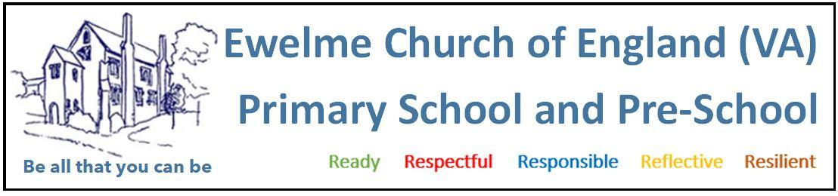
Pre-school SEND policy
INTRODUCTION
Ewelme Pre-School is firmly committed to the integration and inclusion of children with Special Educational Needs and Disabilities (SEND). We maintain a strong network of contacts to ensure appropriate referrals are made and appropriate support is put in place.

OUR COMMITMENT
We are dedicated to enabling all children to fully participate in learning experiences by providing a curriculum that responds to their individual developmental needs. We work in close partnership with parents and relevant external agencies to monitor each child’s progress and to provide effective, targeted support when needed.
As an Ofsted-regulated Early Years provider, we recognise that some children have additional needs (SEND) and take all reasonable steps to ensure they receive the care and support required to promote their welfare and development.

INITIAL CONSULTATION & CARE PLANNING
When a child joins the pre-school, we communicate with parents/carers to discuss any specific needs their child may have—whether dietary, physical, behavioural, or learning-related. This allows us to:
- Understand the child’s needs.
- Assess how best to meet these needs within the setting.
- Ensure quality of care for all children.

GUIDING FRAMEWORK
We aim to adhere to the Department for Education and Skills (DfES) Code of Practice on Special Educational Needs. Ewelme Pre-School recognises every child’s right to a high-quality Early Years experience that combines care and learning through play and education.

Our preschool is sensitive to the needs and feelings of children with SEND and their families. We ensure that individual needs are recognised, respected, and addressed.

PARENTAL INVOLVEMENT
Parents and carers will be actively involved at every stage in the planning and review of their child’s support. Collaboration is key to developing effective strategies that benefit the child.
Also see our ‘Working in Partnership with Parents’ policy.

EQUALITY OF OPPORTUNITY
We believe every child has the right to learn and grow alongside their peers. If your child has additional needs, we will work with you to:
- Support both the child and family.
- Equip staff with the necessary tools and training.
- Access advice and support from relevant outside agencies, including Oxfordshire County Council.
- Make any adaptations required to the environment or curriculum.
- Develop behavioural or educational support plans tailored to your child’s needs.

AIMS AND OBJECTIVES
We aim to:
- Promote an inclusive environment where all children are encouraged to reach their full potential and develop a strong foundation for lifelong learning.
- Provide a broad and balanced curriculum that is accessible and responsive to individual needs.
- Work collaboratively with parents and professionals to monitor progress and plan future support.
- Stay informed of current SEND practices and attend ongoing training opportunities.

SENDCOS (SPECIAL EDUCATIONAL NEEDS AND DISABILITIES COORDINATORS)
- Jayde Gray
Our SENDCO is responsible for overseeing the support of children with SEND and ensuring that all individual needs are being met.

SENDCO RESPONSIBILITIES
- Be familiar with the SEND Code of Practice.
- Work closely with parents, carers, and staff.
- Follow the Assess, Plan, Do, Review model of support.
- Attend regular training and identify training needs of staff and parents where appropriate.
- Liaise with and work alongside outside agencies and professionals.
- Maintain accurate and up-to-date SEND records.
- Ensure records are accessible to key staff, parents, and involved professionals.
- Attend multi-agency meetings as required.
- Ensure children have access to specialist resources when needed.
- Apply for additional funding to enhance support, where possible.

EDUCATION, HEALTH AND CARE PLAN (EHCP)
Some children may require an EHC needs assessment to determine whether an Education, Health and Care (EHC) Plan is necessary. The purpose of an EHC Plan is to outline the additional support a child needs across education, health, and social care to achieve the best possible outcomes.

The local authority is responsible for conducting the EHC needs assessment, taking into account a broad range of evidence, including:
- The child’s developmental milestones and rate of progress.
- Information about the nature, extent, and context of the child’s SEND.
- Evidence of the support and interventions already provided by the nursery.
- Indications that progress has only been achieved through significant additional support.
- Reports on the child’s physical, emotional, and social development, including input from health professionals and other agencies.

We will work collaboratively with the local authority and relevant agencies to ensure that the child receives the support outlined in the EHC Plan to achieve the best possible outcomes.

Policy reviewed: September 2025
Next review due: September 2026

