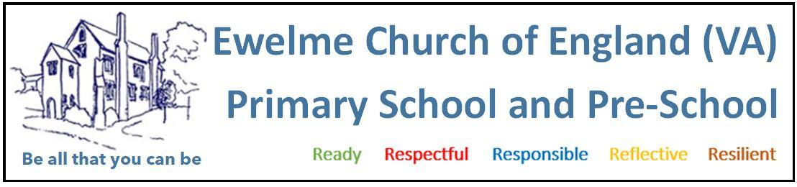
PRE-SCHOOL SAFE SLEEP/ REST POLICY
1. POLICY STATEMENT
At Ewelme Pre-School, we recognise the critical role of sleep in supporting children’s emotional well-being, cognitive development, and physical growth. Quality rest is essential to children’s overall health and development.

We are committed to creating a safe, nurturing, and responsive sleep environment, in partnership with parents and carers, and in line with guidance from:
- The Lullaby Trust
- NHS Safer Sleep Advice
- EYFS Statutory Framework (Revised September 2026)
- Local safeguarding procedures

The safety of every child is paramount during sleep and rest periods.

2. SAFE SLEEP PRACTICE
We adhere to the following evidence-based practices recommended by The Lullaby Trus/NHS safer sleep guidance:
BEFORE SLEEP/REST:
Staff ensure that:
- The child has had a fresh nappy and is clean and comfortable.
- Outer clothing (thick coats, cardigans, hoods, etc.) is removed to avoid overheating.
- The child has had a drink, as appropriate.
- Bibs and hoods are removed prior to sleep.
- The room temperature is appropriate (ideally 16–20°C).
- The room is well ventilated with good air flow

DURING SLEEP:
- Sleep spaces should only contain a firm, flat, waterproof mattress and lightweight bedding which is firmly tucked in and around the child below their shoulders to prevent head covering. Comforters, such as dummies or soft toys, may be used if agreed with parents to help settle children to sleep and then removed once children are asleep Only have cushions for sleep.
- Cots must not contain extra items such as toys, pillows, extra blankets, bumpers, wedges or straps.
- Children are not left to cry alone—staff respond promptly to soothe and comfort.
- Children are regularly monitored and checked visually every 5 to 10 minutes, or more frequently if needed.
- Staff ensure no blankets, muslins, or items cover a child’s face or head at any time.
- Monitoring includes checking for normal breathing, colour, position, temperature and overall well-being
- Children are always within sight and hearing of staff when sleeping

3. PARENTAL PREFERENCES & SLEEP RESTRICTIONS
We value working in partnership with parents and will always discuss sleep routines during settling-in sessions and ongoing key-person meetings.
- If parents request no sleep, we will distract and gently discourage the child from sleeping but will never physically prevent sleep (e.g., by waking or keeping the child upright).
- If a child falls asleep despite efforts, we will allow a minimum of 45 minutes rest, supporting the child’s natural rhythm.
- Children who do not wish to sleep will never be forced to. Instead, they will be offered quiet and calm activities during rest time.

4. WAKING CHILDREN GENTLY
If parents request a maximum sleep time, we will attempt to wake the child gradually and respectfully:
- Lights may be gently brightened.
- Blankets may be lightly removed.
- Soft verbal prompts or the child’s name may be used.
- Children are never physically woken by lifting or shaking.
We aim to allow children to wake naturally, where possible, to prevent distress and ensure emotional security.

5. ADDITIONAL SAFEGUARDING MEASURES
- Staff are trained in safe sleep practice during induction and updated as part of regular safeguarding and health & safety training.
- Sleep areas are regularly cleaned and inspected for hazards.
- All sleep equipment is BS EN compliant (British Standards) and in good condition.
- A Designated Safeguarding Lead (DSL) is notified of any incidents, injuries, or concerns during sleep.

6. MONITORING AND REVIEW
This policy is reviewed annually, or sooner if:
- There is a change in national guidance.
- A serious sleep-related incident occurs.
- Parent/staff feedback indicates the need for review.

Policy reviewed September 2025
Next review due September 2026

