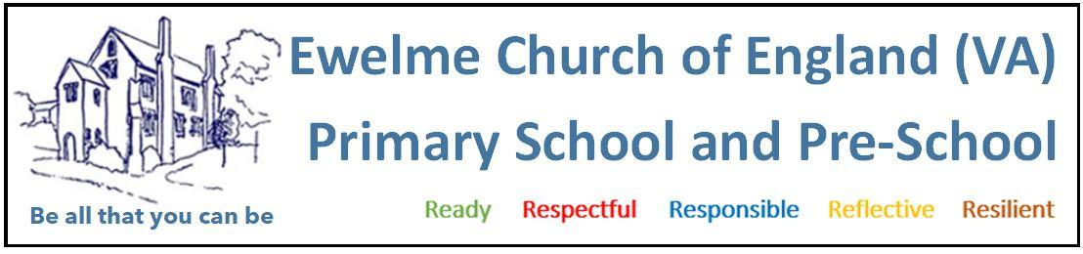
Working in partnership with parents policy

At Ewelme Pre-School, we believe that children thrive best when parents and staff work together in close partnership. We recognise parents and carers as a child’s first and most enduring educators, and our role is to support and complement this. Effective two-way communication and mutual respect are the foundations of our relationship with families.

Our aim is to ensure parents are valued and active participants in their child’s early learning and development journey.

OUR COMMITMENTS:

We will:
- Recognize and support parents as their child’s first and most important educators and actively welcome them into pre-school life.
- Ensure all parents are registered on our online learning journey platform, Class Dojo, which provides updates from pre-school and their children’s development.
- Build parents’ confidence by encouraging them to trust their instincts and judgments about their child.
- Provide accessible communication, offering documents in alternative formats such as Braille, different languages, or electronic forms, tailored to each family’s needs.????
- Welcome parents into the pre-school at any time and operate as flexibly as possible to accommodate their schedules and preferences.
- Ensure all parents are informed about the pre-school’s policies and procedures. Guidance and information is provided on enrolment and full policy documents are available both digitally and in hard copy upon request.
- Maintain regular, meaningful contact with parents to establish a secure and beneficial relationship in support of their child’s development.
- Support parental growth by sharing information about relevant educational opportunities, workshops, and training sessions.
- Encourage parental involvement through open days, stay-and-play sessions, workshops, and social events.
- Communicate pre-school events and updates through newsletters, daily communication tools, and the Class Dojo app.
- Operate a key person system to foster strong relationships, enabling effective two-way information sharing between home and pre-school regarding each child’s individual needs.
- Share planning and progress updates regularly, inviting parents to participate in shared record-keeping.
- Value parent feedback, considering all suggestions regarding their child’s care, learning, or the nursery’s operation.
- Offer parents the opportunity to contribute their knowledge, interests, and skills to enrich nursery activities.
- Inform parents of procedures for registering queries, compliments, complaints, or suggestions, ensuring transparency and understanding. A written complaints policy is available to all families.
- Promote understanding of the Early Years Foundation Stage (EYFS) and provide guidance on how learning can be supported at home.
- Establish clear agreements through written contracts outlining terms of acceptance, fees, and funding arrangements.
- Respect cultural, religious, and individual family backgrounds, accommodating special requirements wherever practical.
- Seek regular feedback via questionnaires, suggestions, and/or informal discussions to help evaluate and enhance pre-school practice, policy, and staff development. Staff reviews due as discussed.

Policy Reviewed September 2025
Next review due September 2026

